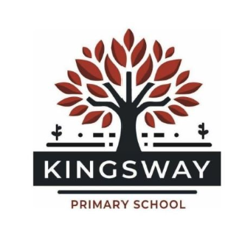

A RELATIONAL APPROACH TO POSITIVE BEHAVIOUR MANAGEMENT
Mission Statement
‘Inspired to make a difference together’ to achieve our shared vision that ‘each child thrives from the moment they arrive.’

School values
We care about TOGETHERNESS
We thrive on DIFFERENCE
We are PASSIONATE ABOUT LEARNING
We are INSPIRED TO GROW

Building positive relationships between staff and children is a fundamental aspect of high-quality teaching and learning. It promotes a sense of school belonging and encourages children to participate in their own development actively. We can assist and develop children’s resilience and ambition, and help them become reflective learners, as well as being there for support and guidance.
Staff are responsible for taking the necessary steps to ensure that all children are supported in overcoming their individual barriers to success. This includes all staff taking responsibility for being aware of every child’s individual needs – whether academic, social/emotional, physical, learning or pastoral. Kingsway is an inclusive school and as such, everyone in our community must work together to ensure that we meet the needs of all our learners.
Often relationships struggle and dysregulated behaviours occur where learning, activities and provision are not best pitched to best meet the needs of learners. Some children have particular challenges through the complexity of their needs; learning, emotional, behavioural or attendance. Through acknowledging these needs, proactively planning for them and responsively adapting provision, staff can facilitate a better relationship, more regulated behaviours and better learning outcomes.

Our Rights and Responsibilities
Rights | Responsibilities
To learn | We let everyone learn
To achieve | We always try our best
To belong | We value and include everyone
To be safe | We do not hurt others
To be cared for | We look after each other
This policy has been created using the United Nations Conventions the Rights of the Child to keep the children at Kingsway Primary School safe and happy.

Aims of the Policy
· To create an environment that embodies our school’s vision and values and promotes positive well-being for all.
· To support all in our school community – including pupils, staff, parents/carers and wider stakeholders – with exemplifying our values at all times.
· To provide a safe, happy and nurturing environment where all individuals have a sense of belonging, are valued and thrive.
· To facilitate all pupils and staff in working towards excellence through high-quality challenge and support.
· To assist all pupils and staff in consistently meeting the school’s high standards and expectations for their attitude, behaviour and communication.
· To maintain a calm, purposeful and nurturing atmosphere where all pupils and staff are ready to learn, develop and grow.
· To foster, nurture and value healthy, trusting relationships. (We do not use shouting and public shaming)
· To develop resilience, through positive relationships, for all pupils and staff.

Underlying Principles
· Positive relationships between all members of our school community are imperative to our practice, buffer stress and build resilience.
· Children and adults have a sense of belonging, feel safe, secure and valued at our school.
· People learn to cope with all aspects of their lives with support from others.
· The importance of fostering social relationships and mutual engagement in a school community.
· Responsibility for one’s own attitude and actions and their impact on others.
· Respect for other people, their views, feelings and circumstances.
· Empathy with the feelings of others – including where they are affected by one’s own actions.
· Fairness and equality.
· Active involvement of everyone in school with decisions about their own lives.
· A willingness to create opportunities for reflective change in pupils and staff.
· Commitment to not engage in behaviours and actions that can bring feelings of shame for others.
· Understanding that ‘all behaviour is communication’ for both children and adults.

Key Principles based around the School Values
- Caring about Togetherness:
  - Building Community: Foster a sense of belonging by encouraging collaborative activities, group learning, and school-wide events.
  - Positive Reinforcement: Use positive reinforcement to celebrate acts of kindness, cooperation, and teamwork.
  - Restorative Practices: Implement restorative practices to resolve conflicts and repair relationships, ensuring that all parties feel heard and valued.
- Thrive on Difference:
  - Celebrating Diversity: Acknowledge and celebrate the diverse backgrounds, talents, and perspectives within our school community.
  - Inclusive Practices: Ensure that all children have equal opportunities to participate and succeed, adapting support to meet individual needs.
  - Cultural Awareness: Integrate cultural awareness and sensitivity into the curriculum and daily interactions.
- Passionate about Learning:
  - Growth Mindset: Encourage a growth mindset by recognizing effort, resilience, and progress rather than just outcomes.
  - Intrinsic Rewards: Use intrinsic rewards such as verbal praise, personal satisfaction, and recognition of effort to motivate children.
  - Student Voice: Involve children in decision-making processes about their learning and school activities, fostering a sense of ownership and responsibility.
- Inspired to Grow:
  - Personal Development: Support children in setting personal goals and reflecting on their achievements and areas for improvement.
  - Mentorship: Provide mentorship opportunities where older children can guide and support younger peers.
  - Holistic Well-being: Address the social, emotional, and academic needs of children, promoting overall well-being and resilience.

Related Policies
Behaviour principles written statement
Relational Approach Policy
Child Protection and Safeguarding Policy
Anti-bullying and harassment
Positive handling
Exclusions
PSHE and SRE
Staff wellbeing
Staff Code of Conduct

Staff Responsibility
Developing positive and supportive relationships with pupils is the responsibility of all members of staff within the school community. Staff will be prepared to listen and hear everyone’s perspective, striving to understand the feelings and emotions that might drive certain behaviour, whilst maintaining clear boundaries and expectations. Our staff have an understanding that being ‘fair’ is not about everyone getting the same (equality) but about everyone getting what they need (equity) or removing barriers wherever possible to create inclusivity (See Appendix 1). Our staff promise to promote positive behaviour, remind pupils of their responsibilities and exercise a kind and consistent approach to behaviour improvement.

The Role of the Class Teacher
It is the responsibility of the class teacher to provide a safe and secure learning environment, which includes clear and consistent boundaries with routines and structure. Class teachers consistently maintain high expectations of pupils with regard to behaviour, and strive to ensure pupils work to their potential, living and breathing the value ‘We care about togetherness’. The teacher is a social, emotional and learning role model for all pupils, demonstrating how to treat others with respect and understanding. When the class teacher is not responsible for their class, the adult in charge adheres to this policy in order to maintain a culture of certainty for the children.

The Role of Parents and Families
Parents agree to a Working Together Agreement when enrolling their child at our school. The expectations are that parents/guardians will adhere to the Working Together Agreement and support the actions of the school. Parents are able to address any concerns or queries regarding emotion coaching, self-regulation and restorative approaches firstly to the class teachers, then to a member of the senior leadership team and finally to the Deputy Headteacher and Headteacher of the school. Our aim is to work with families to achieve a shared and consistent approach between home and school to support their child’s emotional and behavioural development.
A tiered approach to behaviour management - notes of guidance for members of staff:
When supporting a child to regulate their behaviour, all staff must follow our relational approach policies – the first step of which is to make sure that you are self-regulating effectively.
- When dysregulated behaviour occurs, it is the class teacher’s /supervising adult’s responsibility to respond as they have the most meaningful relationship with the child in school. In being proactive, anticipating potential triggers and barriers and taking steps to prevent dysregulation, all staff can have a positive impact. Below are some things for all staff to consider and act on in order to prevent dysregulated behaviour occurring:

- During Learning Time:
  - Is the learning pitched correctly? Can the child access the learning in full? How do you know? What adaptations to the curriculum are needed in order to make it accessible?
  - What further learning scaffolds are required?
  - How can you provide further challenge within their learning?
  - What adjustments to iQFT are required – for example seating plans, use of resources, visual prompts, peer support, feedback or pre/post teaching? What support might you need to implement these?
  - How are additional adults in the classroom deployed? How can the class TA be redirected to facilitate the child in accessing their learning?
  - What opportunities are you providing for regular co-/self- regulation activities within your lessons/day as a class or in smaller groups?
  - How are adults in the classroom modelling a relational way of being and using Emotion Coaching with children?

- During Social Time:
  - What structures or scaffolds does the child need to stay regulated during social or unstructured times? – For example routine, social stories, buddies, adult-led activities, resources for games to play etc. Remember that patterned, rhythmic activities are soothing and support self-regulation and are ideal for play times.
  - What support does the child need in making friends and sustaining peer relationships?
  - What can you do to support the child in learning how to resolve friendship issues and conflicts appropriately? For example, using social stories.
  - Which adults can be deployed to proactively support with and teach self-regulation through co-regulation and planned activities? For example class TA, 1:1 TA or class teacher.
  - Where there has been conflict or damage within a relationship, what support might the child need in accessing restorative practice?

Recording information following incidents or dysregulated behaviour
All incidents MUST be recorded on CPOMS.
When recording on CPOMS, the following prompts may be helpful:
- Remember to be as factual as possible – don’t include personal opinion or emotive language.
- Include any further action which is taken, including who by and when.
- Where did the behaviour / dysregulation take place?
- What time of day did it occur?
- What led up to the behaviour incident? What were the triggers?
- What happened? Remember to be factual.
- What actions were taken to de-escalate the behaviour? What was the impact of these?
- What patterns have you noticed in relation to dysregulation and / or incidents with the child?
- Who was impacted and how?
- How has the situation been resolved? What were the outcomes?
- If multiple children were involved, how have they been supported to repair their relationships? See restorative practice prompts below.
- What action needs to be taken next? Who is responsible and when by?
- What impact did the action have? This will need to be added as a “follow-up action” on the system.

Restorative practice
A restorative conversation is more than a process or a set of questions. The behaviour of the adult lies at the heart of it.
Small things matter…
- Body Language
- Meeting Place
- Tone of Voice
Consider:
- Going outside
- Walking alongside the child and talking
- Engaging in a collaborative activity
- Sitting alongside in a neutral and familiar space.

10 Ways to Make a Restorative Meeting Work
- Don’t sit behind or on a desk.
- Focus on the outcome you want, not the behaviour that necessitated the meeting.
- Reserve enough time.
- Don’t make copious notes.
- Have a glass of water available for the pupil.
- Leave the door open.
- Try not to use judgemental language.
- Resist any interruptions to the meeting, inform anyone who interrupts that this meeting is important.
- Don’t comment on negative secondary behaviours such as, appearance or tidiness of uniform – missing tie, untucked shirt etc.
- End the meeting positively, plan the conclusion and don’t open up any other business.

Think about the question prompts below to support you with structuring the conversation:

- What happened?
- What were you thinking at the time?
- What have you thought since?
- How did this make people feel?
- Who has been affected?
- How have they been affected
- What can we do to put it right?
- How can we do things differently?
Natural consequences should be individual to the child. They should come from the restorative conversation and should be decided on and shared with the child. Some children will need guidance with this part and making sure they understand why.
Watch out for:
- Mentioning the meeting in front of other pupils, it can destroy the trust. If you need to remind the child of the undertakings they agreed then do so privately.
- Expecting every meeting to go well just because you are calm, kind and well planned. Restorative conversations take time to have an impact on some children. Some will deliberately sabotage the meetings at first to see if you can be bothered to continue with them. They might find it hard to look in the mirror that is being held up in front of them. Reflective thought processes take time.

3 Things to do when Pupils Won’t Talk
- Make it less personal: ‘Ok imagine if there were – people affected / a way of putting it right / things you could do differently – What would they be?’
- 1:10 Scales: ‘On a scale of 1 to 10 how angry were you?’
- Offer a postponement if the child is not ready: ‘I can see that you are not quite ready to talk, do you need more time? Would you like to do it tomorrow?’
Top Tips
- Answer the questions yourself too. This is a dialogue and modelling responses may help.
- Restorative meetings must not be preludes to apologies. If they are then there can be tension in the room and some expectation that the child gives certain answers that they think the adult wants to hear. If the restorative meeting is going to be productive then everyone should be free to speak. A forced apology does not teach humility, it simply underlines obedience.
Adults Who Say Sorry
An adult who sincerely apologising for a genuine error in front of a group or a class of children has a truly transformative effect. The humility is obvious, trust is repaired and becomes even stronger than before. Adults should not be expected to be perfect in every situation and the process of making a mistake and learning from it should be modelled by staff in school – our school is a place of psychological safety.
Communication with parents/carers
Where incidents or dysregulated behaviour are being recorded on CPOMS, it is essential that parents/carers have been informed and their views are recorded too. It is expected that this will be actioned by the class teacher. When informing parents/carers please consider the following:
- Check that you are regulated first.
- What is the best way to communicate with the parent/carer for the conversation to be productive and helpful – face-to-face at drop-off or pick-up, an arranged appointment, phone call and will translation be needed?
- What do you need to say to help the parent/carer have a clear understanding of the incident that has occurred?
- Make sure that you are empathetic, non-judgmental, factual and relational in your communication.
- What strategies, actions and support will you inform the parent/carer have been put in place to facilitate self-regulation and prevent repeat occurrences in the future?
- Remember to feedback to the child and the parent/carer on any positive behaviours and strengths that are noticed following the incident.
- What can the parent/carer do to support and work in partnership with you?
- You might want to ask, how has the child been at home recently? Has the parent/carer noticed any changes in their behaviour or mood? What does the parent/carer find helps soothe, calm and regulate the child at home? What triggers or patterns in their dysregulation has the parent/carer noticed? What communication would the parent/carer like moving forward?
When a concern is raised by the parent/carer of a child in your class, the class teacher will arrange a telephone call or face-to-face meeting with them to listen to their concerns in full and agree what actions will be taken by the class teacher to address the concerns.
Actions may include:
- Talking with individuals/groups of children and/or whole classes relationally to promote positive relationships, behaviour and regulation and outline school expectations as part of firm, clear and consistent boundaries.
- Delivering a PHSE session or holding circle time discussions where appropriate
- Planning in further opportunities for relationship-building and/or co-regulation activities
- Rewarding the positive learning behaviours of others using specific praise
- Appropriate use of rewards (values-based stickers, team points, celebration certificates etc.)
- Re-direction of TA support where applicable and appropriate
- Use of a positive learning behaviour chart or contract (if directed as an intervention by external professionals)
- Home school communication book
When a member of staff does not feel confident in effectively managing conversations around the behaviour, regulation and/or concerns of a child in their class, advice can be sought from the EYFS Lead, SENCO, Deputy Headteacher or Headteacher and coaching will be provided. This coaching may be in the form of skills practice conversations, signposting to further information and training or via using the “watch one/do one” approach.

The diagram below outlines the school’s tiered approach to addressing incidents when dysregulation occurs. These should always be used in conjunction with the relevant school policy documents – in particular the relational approach policies.
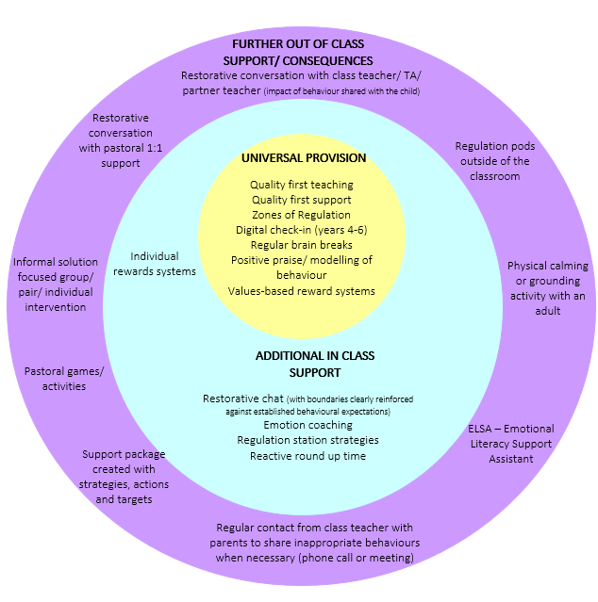
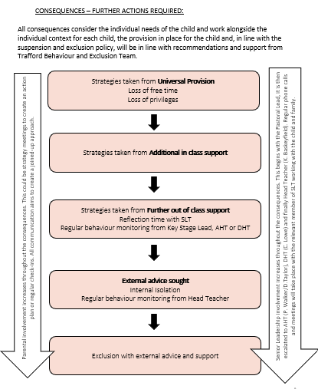
This policy will be applied to all children, however, there may be time when individual children require a personalised intervention as directed by external professionals.
How we support staff well-being
We recognise that traumatised children often try to control the emotions of the adults in their lives. This climate of conflict can be more familiar for children who has attachment and trauma in their lives than calm, considerate interactions. Practices that help teachers remain calm and avoid direct struggle for control, will be most effective.
To support staff well-being at Kingsway we work collaboratively, ask for help and support each other. We discuss with other staff how they manage classes/children and learn from each other - sharing expertise and good practice. We have a Relational Approach policy for the whole school and our line management process is based on coaching and mentoring to support this.
We have regular CPD in place for staff on how to promote children’s well-being and how to support children’s individual needs. All staff have attended high-quality training on attachment, trauma and de-escalation techniques.
Staff can access practical support through a variety of ways including, but not limited to;
- SENCO support
- Pastoral support
- Well-being and Mental Health First-Aider support
- Supervision sessions
- Speech Therapy
- Educational Psychologist
- EAP service provided by school
- Wider leadership support both informally and formally including Key Stage leads and senior leaders.
The Senior Leadership Team ensures that staff well-being and work life balance is always given high priority in any decisions that are made. This package of support ensures that staff at Kingsway feel valued and supported and are able to meet the needs of all children including those with complex individual needs.
Intrinsic Reward System
As part of training undertaken and research gathered the school has adopted intrinsic reward systems in school.
Implementing an intrinsic reward system involves fostering internal motivation in children, so they learn to value the process of learning itself, not just external rewards like points. The goal is to help children feel a sense of accomplishment, autonomy, and a love for learning.
Here’s how we aim to do that:

1. Focus on Mastery and Effort, Not Just Outcomes
- Emphasise growth and improvement: Encourage children to reflect on their progress. Praise their effort, persistence, and strategies rather than only the results.
- Celebrate personal bests: Help children track their own progress and improvement, comparing their work to previous efforts rather than comparing them to peers.

2. Provide Autonomy in Learning
- Offer choices: Let children choose topics for projects, books to read, or methods to demonstrate their learning. Giving them ownership helps build intrinsic motivation.
- Encourage self-directed learning: Teach children how to set their own goals, plan their work, and monitor their progress. This fosters independence and a sense of responsibility.

3. Cultivate Curiosity and a Love for Learning
- Make learning engaging and relevant: Design lessons that spark curiosity and connect to children’ interests. Show how what they learn in class applies to real life.
- Encourage inquiry and creativity: Allow children to ask questions, experiment, and explore topics in depth. When they feel excited about what they’re learning, they are more likely to be intrinsically motivated.

4. Provide Meaningful Feedback
- Use formative feedback: Give specific, constructive feedback that helps children understand how they can improve. This focuses on learning rather than just final grades.
- Praise effort and strategy: Acknowledge when children try hard or use creative strategies, which reinforces their internal satisfaction from working hard.

5. Foster a Growth Mindset
- Teach that intelligence and abilities can grow: Encourage children to view challenges as opportunities to learn and grow, rather than as threats to their abilities.
- Model a positive attitude toward mistakes: Help children see mistakes as valuable learning experiences rather than failures.

6. Build Relationships and a Positive Classroom Environment
- Create a supportive and collaborative culture: Encourage children to work together, share ideas, and celebrate each other’s successes.
- Develop teacher-student relationships: When children feel understood and valued by their teacher, they are more motivated to engage in learning.

7. Encourage Reflection and Goal Setting
- Promote self-reflection: Have children reflect on their learning process, what they’ve learned, and how they can apply it in the future.
- Support goal setting: Help children set short- and long-term learning goals, and regularly revisit these goals to assess progress and make adjustments.

8. Minimize External Rewards and Competition
- Limit use of extrinsic rewards: Reduce the emphasis on external motivators like stickers, prizes, or high grades. Instead, focus on intrinsic motivators such as a sense of mastery, accomplishment, or the joy of learning.
- Discourage unhealthy competition: Promote collaboration over competition by designing activities where children work together to achieve shared goals.

Examples in Practice
- Inquiry-based learning projects where children explore topics of interest.
- Child-led conferences where children present their progress and reflections.
- Peer teaching opportunities, where children share knowledge with classmates.
By creating an environment that prioritises curiosity, growth, autonomy, and meaningful learning experiences, you can build an intrinsic reward system that motivates children from within.
Team points are used within school and children are in the same teams as their family members. Our teams, created by the children, are: Phoenix, Unicorns, Griffins and Dragons. Team points are given when the children have demonstrated behaviours that show any of our four values.
Children’s behaviours showing the values are also recognised on ‘Our Amazing Things Today’ charts within each classroom.
By embedding the principles and strategies talked about in this policy into our daily practices, we aim to create a school environment where every student feels connected, valued, and motivated to learn and grow. Our intrinsic reward system and commitment to our core values will help children develop into well-rounded individuals who are prepared to thrive in a diverse and ever-changing world.
Appendix One
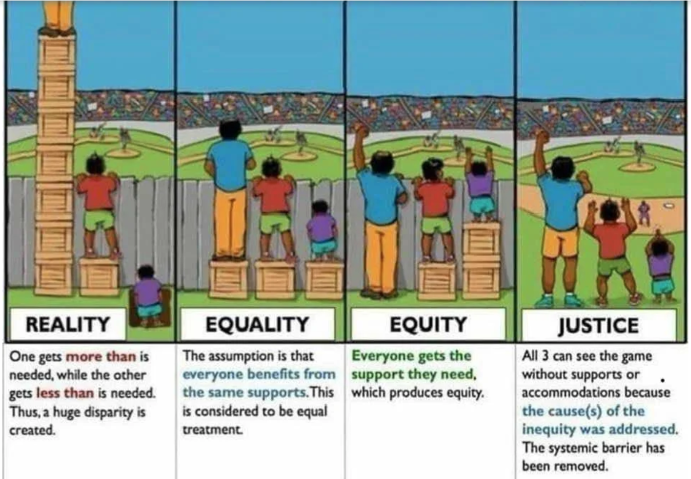
INCLUSION

Appendix Two
Promoting Pupil Engagement and Self-Regulation
Seven Basic Principles Which Guide Us
Research taken from ‘No Drama Discipline’ – Daniel Siegel 2015

Appendix Three
Emotion Coaching

We use emotion coaching to support children to understand, regulate and reflect on their behaviour. This strategy involves using relationship building to support pupils in feeling safe, develop their ability to calm down quickly and build connections between their survival brain and human brain.

We use the Zones of Regulation to help children learn to understand how a feeling relates to an emotion. These are on display in all classrooms and shared areas.
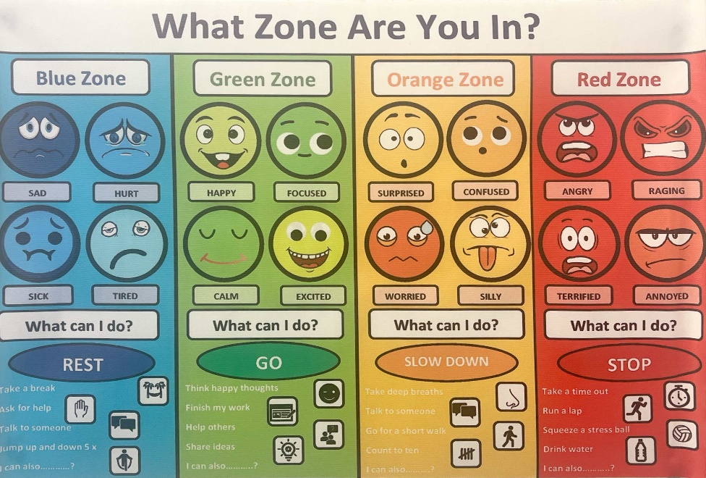

Appendix Four

Appendix Five – Top Tips support for staff at Kingsway
Conversation Extenders

- In certain situations where the adult is trying to build a relationship with a child who struggles to articulate their feelings it is common for the adult to try to provide the answers for the child and to suggest solutions that the child is not ready or able to buy into. Instead of overly leading the child into a solution they are not yet equipped for try instead, in certain circumstances, extending the conversation using prompts that encourage the young person to reflect more fully on their situation and how they are experiencing it.
- I was wondering about…
- I was wondering about how you might feel about / what you might do / what you think might help…
- I think what you’re saying / telling me is…
- It sounds like you are feeling…
- I noticed you said / did when…
- I’m not sure whether I’ve got this right but…
- I have the impression that you might be thinking / feeling…I this right?
- Perhaps you’d like to talk some more about that…
- That sounds quite tricky, maybe we need more time to think about that…
- I’m wondering what might help…
- Is there a time when it doesn’t feel so bad? I’m wondering what might be different then, how would you describe yourself then…
- We can think together about things that might help, if you like?

Toolbox of Support
Strategies which can be used with pupils as part of their Universal provision and Quality First Teaching to support with behaviour.

- Sand timers
- Weather and wings cards for regulation
- Kindness nomination box
- Proud book
- Home school diary
- Class vs. teacher tally chart
- Wobble cushion
- Fidget toys
- Ear defenders
- Supportive learning partners
- Golden cushion
- Concentration stations
- Worry jars/ monsters
- Visual prompts
- Personalised visual timetables
- Personal note books/ doodle books
- Celebration displays
- Peer support and positive role models from other year groups
- Use of story time to reinforce messages
- Social story
- Classroom jobs or roles
- Weekly check-ins with a trusted adult
- Classroom positioning
- Varied timetable
- Settling time at transition points
- Classroom checklists
- Instructions broken into small steps/ visually presented
- Daily reminders of success

The Restorative 5 – Choose 5 from 8
- What happened? Listen carefully and without interruption to the child’s account of the incident. Give your account of the incident from your perspective, without judgment.
- What were you thinking at the time? This reflection helps the pupil reconsider their actions and replay their thought processes. What may have seemed irrational at the time to you may not be obvious to the child that it was those initial thoughts that started the behaviour that sent them down the wrong path.
- What have you thought since? Many doors are opened through this question that might allow the pupil a change in attitude or a shift in explanation. Some of their thoughts will have been negative, some will lead the conversation off on a tangent and others will cut to the root cause of the problem.
- How did this make people feel? The child is often unaware of how other people reacted during the episode of extreme or inappropriate behaviour. We want to make sure that the child has the opportunity to consider others and to think about the impact their behaviour has on others who witness it.
- Who has been affected? The first response is usually ‘me, me, me and then me!’ but after some gentle encouragement children tend to see the bigger picture. The more this question is asked, the easier it becomes for the pupil to answer it. In time that reflective routine might affect how they act before or during incidents. This is teaching them to use their conscience.
- How have they been affected? Considering how others felt during an incident and deliberately encouraging the chid to have empathy with other people is important, Understanding how their behaviour affects others is key to being a good citizen.
- What should we do to put things right? Don’t demand an apology, even if these seems like the logical next step. Forced apologies are worthless. If an apology is forthcoming though, don’t criticise its delivery or sincerity.
- How can we do things differently in the future? Forward thinking and visualisation is positive. It is likely that the child will meet similar situations or frustrations in the future. Some prior planning will help them recognise when their behaviour pattern begins. This does not mean that they will immediately be able to change direction but they will be ware of their poor choices.
Restorative Questions for Younger Children
Asking 5 questions to some younger children may be too much. Instead choose 2 or 3 that are pertinent to the incident or that you want to focus on with a particular child.
Often the focus should be 5 & 7.

Picking Up Your Own Tab

Children don’t learn how to behave once. They learn and relearn behaviours with everyone they meet.
They learn who passes on responsibility too quickly, they learn who relies too heavily on process and procedure, they learn who gives sanctions too readily and they learn who does not always follow up on behaviour.

Children learn if they escalate their behaviour quickly enough then they get dealt with by senior staff, they get closer to the centre of the power and are not accountable to teaching staff any longer.
If behaviour issues are systematically passed up the line, teachers are denied the opportunity to follow up effectively. This routinely undermines the authority of the class teacher by pretending that further up the chain of command there is a magic bullet.
- Poor behaviour needs to be managed in teams: at source.
In the management and improvement of behaviour, follow up is key. Establishing true consistency and ensuring all pupils, regardless of their reputation, are dealt with personally.
- My classroom – My responsibility – My consistency.

