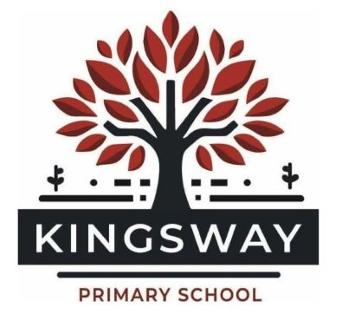

Kingsway Primary School Art and Design Policy

1. Aims and Vision
At our school, Art and Design is a vital part of a broad and balanced curriculum. We believe that all children should be given the opportunity to explore, experiment, and express themselves creatively.
Our Art curriculum is underpinned by our core values:
- We care about togetherness – we collaborate, share ideas, and celebrate one another’s creativity.
- We thrive on difference – we value individuality and encourage diverse artistic expression.
- We are passionate about learning – we foster curiosity, resilience, and pride in artistic processes.
- We are inspired to grow – we support children to reflect, refine, and develop their skills over time.
Through Art and Design, pupils develop confidence, imagination, and a sense of identity while engaging with the world around them.

2. Curriculum Intent
Our Art and Design curriculum is designed in line with the National Curriculum for Art and Design and aims to ensure that all pupils:
- Produce creative work, exploring ideas and recording experiences
- Become proficient in drawing, painting, sculpture, and other techniques
- Evaluate and analyse creative works using the language of art, craft, and design
- Know about great artists, craft makers, and designers, and understand the historical and cultural development of their art forms
We deliver a reading-inspired curriculum, where high-quality texts are used to inspire artistic outcomes. Books act as a stimulus for ideas, themes, and discussion, allowing children to make meaningful cross-curricular connections.

3. Curriculum Implementation
Structure of Art Provision
- Each year group completes three Art units per academic year
- Each unit is carefully sequenced to build knowledge, skills, and techniques progressively
- Every unit culminates in an Art Day, where pupils create a final outcome, celebrate their work, and engage in immersive creative experiences
Sketchbooks
Sketchbooks are central to our Art curriculum and are used to:
- Record observations, ideas, and experimentation
- Practise and refine techniques
- Reflect on artistic choices and progress
- Showcase each child’s individual artistic journey over time
Sketchbooks are valued as a working document rather than a finished product and celebrate the process of learning.
Teaching Approach
Teaching in Art and Design includes:
- Explicit teaching of artistic skills and techniques
- Opportunities for exploration, experimentation, and risk-taking
- Exposure to a wide range of artists, cultures, and styles
- Use of subject-specific vocabulary to support critique and discussion
- Regular opportunities for reflection and evaluation
Arts Week
Every two years, we hold a whole-school Arts Week, which:
- Celebrates creativity across the curriculum
- Provides immersive artistic experiences
- Encourages collaboration across year groups
- Showcases children’s work to the wider school community

4. Inclusion and Equal Opportunities
We believe that Art and Design is for every child.
- Lessons are adapted to ensure full participation for all learners
- Children are encouraged to express their individuality and cultural identity
- A range of materials and approaches are used to support different needs and learning styles
- High expectations are maintained for all pupils

5. Assessment
Assessment in Art and Design is ongoing and formative.
Teachers assess pupils through:
- Observation of practical work
- Discussion and questioning
- Review of sketchbooks
- Final outcomes at the end of each unit
Assessment focuses on:
- Skill development
- Creativity and originality
- Ability to evaluate and refine work
- Progress over time

6. Impact
The impact of our Art and Design curriculum is seen in:
- Confident, creative pupils who can express their ideas visually
- A clear progression of skills and knowledge across the school
- High-quality sketchbooks that demonstrate each child’s journey
- Pupils who can discuss and evaluate art using appropriate vocabulary
- A love of art and creativity that extends beyond the classroom

7. Monitoring and Review
The Art and Design subject leader is responsible for:
- Monitoring teaching and learning across the school
- Reviewing sketchbooks and outcomes
- Supporting staff with planning and subject knowledge
- Ensuring progression and consistency
- Reviewing this policy regularly to ensure it remains effective and relevant

